Task 1:
import java.util.*;

class Solution {

public static long stringSimilarity(String s) {
int n = s.length();
long total = 0;

for (int i = 0; i < n; i++) {
int j = 0;

// Compare prefix with suffix starting at i
while (i + j < n && s.charAt(j) == s.charAt(i + j)) {
j++;
}

total += j;
}

return total;
}

public static void main(String[] args) {
Scanner sc = new Scanner(System.in);

int t = sc.nextInt();
while (t-- > 0) {
String s = sc.next();
System.out.println(stringSimilarity(s));
}

sc.close();
}
}
Output :
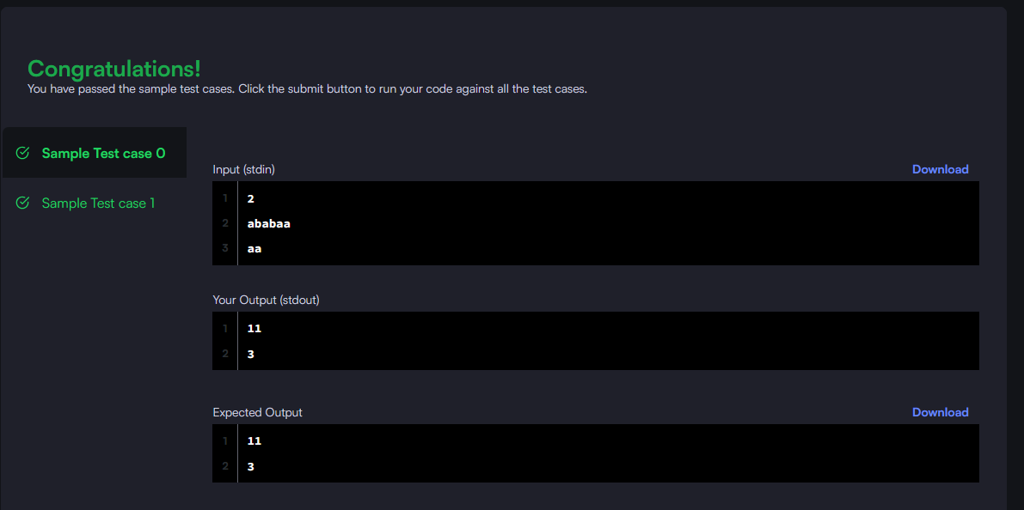
Task 2:
class Solution {
public boolean repeatedSubstringPattern(String s) {
String doubled = s + s;

// Remove first and last character
String sub = doubled.substring(1, doubled.length() - 1);

return sub.contains(s);
}
}
Output :
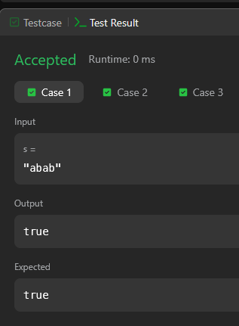
Task 3:
import java.util.*;

class Solution {

public static String twoStrings(String s1, String s2) {
Set<Character> set = new HashSet<>();

// Store characters of s1
for (char c : s1.toCharArray()) {
set.add(c);
}

// Check if any character exists in s2
for (char c : s2.toCharArray()) {
if (set.contains(c)) {
return "YES";
}
}

return "NO";
}

public static void main(String[] args) {
Scanner sc = new Scanner(System.in);

int t = sc.nextInt();

while (t-- > 0) {
String s1 = sc.next();
String s2 = sc.next();

System.out.println(twoStrings(s1, s2));
}

sc.close();
}
}
Output :
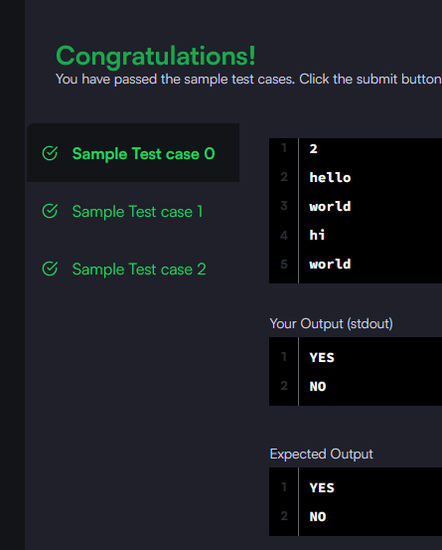
Task 4:
class Solution {
public boolean rotateString(String s, String goal) {
// Length must be equal
if (s.length() != goal.length()) {
return false;
}

// Check if goal is a substring of s + s
String doubled = s + s;
return doubled.contains(goal);
}
}
Output :
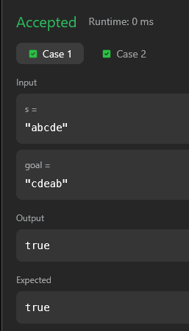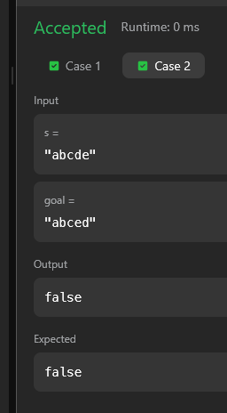
Task 5 :
import java.util.*;

class Solution {

public static int marsExploration(String s) {
int count = 0;
String pattern = "SOS";

for (int i = 0; i < s.length(); i++) {
if (s.charAt(i) != pattern.charAt(i % 3)) {
count++;
}
}

return count;
}

public static void main(String[] args) {
Scanner sc = new Scanner(System.in);

String s = sc.next();

int result = marsExploration(s);
System.out.println(result);

sc.close();
}
}
Output :
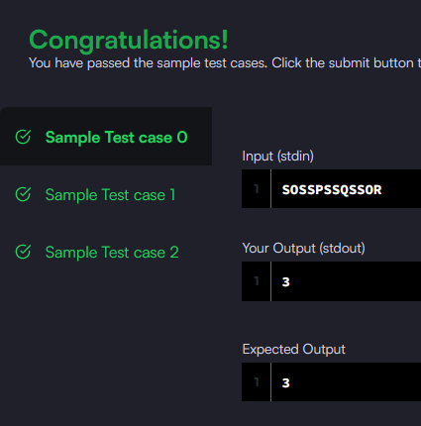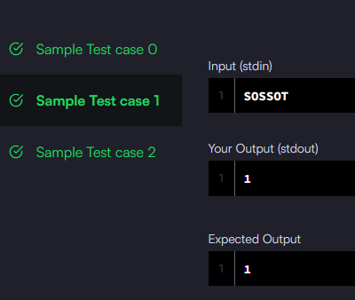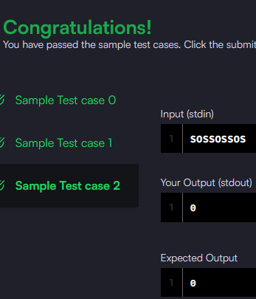
Task 6:
import java.util.*;

class Solution {
public List<Integer> findAnagrams(String s, String p) {
List<Integer> result = new ArrayList<>();

int n = s.length();
int m = p.length();

if (n < m) return result;

int[] pCount = new int[26];
int[] sCount = new int[26];

// Count frequency of p
for (int i = 0; i < m; i++) {
pCount[p.charAt(i) - 'a']++;
}

// Sliding window
for (int i = 0; i < n; i++) {
// Add current character
sCount[s.charAt(i) - 'a']++;

// Remove leftmost character when window size exceeds m
if (i >= m) {
sCount[s.charAt(i - m) - 'a']--;
}

// Compare frequency arrays
if (Arrays.equals(pCount, sCount)) {
result.add(i - m + 1);
}
}

return result;
}
}
Output :
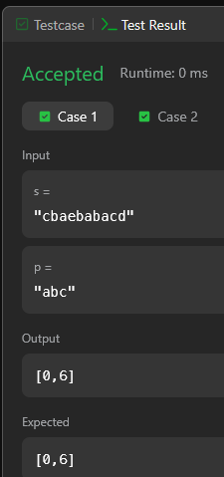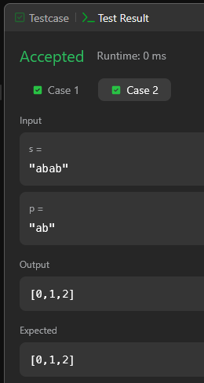

Task 7:
import java.util.*;

class Solution {

public static int palindromeIndex(String s) {
int left = 0;
int right = s.length() - 1;

while (left < right) {
if (s.charAt(left) == s.charAt(right)) {
left++;
right--;
} else {
// Try removing left OR right
if (isPalindrome(s, left + 1, right)) {
return left;
} else if (isPalindrome(s, left, right - 1)) {
return right;
} else {
return -1;
}
}
}

return -1; // already palindrome
}

private static boolean isPalindrome(String s, int l, int r) {
while (l < r) {
if (s.charAt(l) != s.charAt(r)) {
return false;
}
l++;
r--;
}
return true;
}

public static void main(String[] args) {
Scanner sc = new Scanner(System.in);

int q = sc.nextInt();

while (q-- > 0) {
String s = sc.next();
System.out.println(palindromeIndex(s));
}

sc.close();
}
}
Output :
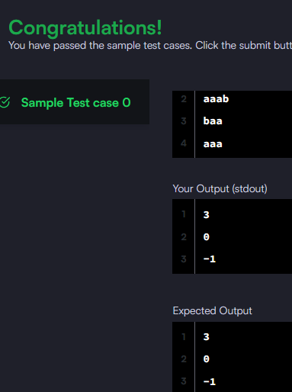
Task 8:
class Solution {
public int strStr(String haystack, String needle) {
int n = haystack.length();
int m = needle.length();

// Edge case
if (m > n) return -1;

for (int i = 0; i <= n - m; i++) {
int j = 0;

// Compare substring
while (j < m && haystack.charAt(i + j) == needle.charAt(j)) {
j++;
}

// If full match found
if (j == m) {
return i;
}
}

return -1;
}
}
Output :
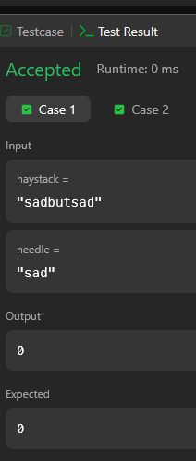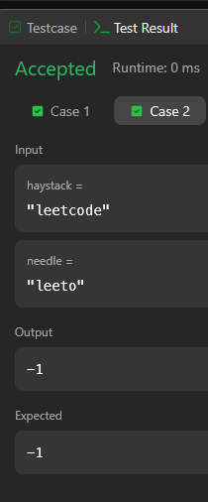
Task 9:
class Solution {
public String longestPalindrome(String s) {
if (s == null || s.length() < 1) return "";

int start = 0, end = 0;

for (int i = 0; i < s.length(); i++) {
int len1 = expand(s, i, i); // odd length
int len2 = expand(s, i, i + 1); // even length

int len = Math.max(len1, len2);

if (len > end - start) {
start = i - (len - 1) / 2;
end = i + len / 2;
}
}

return s.substring(start, end + 1);
}

private int expand(String s, int left, int right) {
while (left >= 0 && right < s.length() &&
s.charAt(left) == s.charAt(right)) {
left--;
right++;
}
return right - left - 1;
}
}
Output :
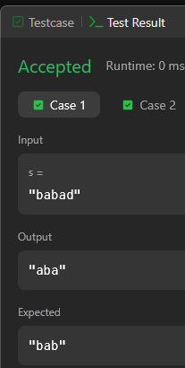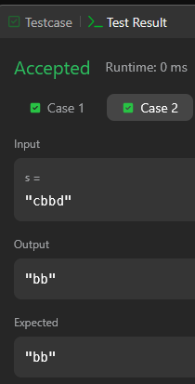
Task 10:
import java.util.*;

class Solution {

// Function to find longest palindromic substring length
public static int longestPalindrome(String s) {
int maxLen = 1;

for (int i = 0; i < s.length(); i++) {
// Odd length
maxLen = Math.max(maxLen, expand(s, i, i));
// Even length
maxLen = Math.max(maxLen, expand(s, i, i + 1));
}

return maxLen;
}

private static int expand(String s, int left, int right) {
while (left >= 0 && right < s.length() &&
s.charAt(left) == s.charAt(right)) {
left--;
right++;
}
return right - left - 1;
}

public static void main(String[] args) {
Scanner sc = new Scanner(System.in);

int n = sc.nextInt();
String s = sc.next();

for (int k = 0; k < n; k++) {
// Create rotation
String rotated = s.substring(k) + s.substring(0, k);

// Find longest palindrome length
int ans = longestPalindrome(rotated);

System.out.println(ans);
}

sc.close();
}
}
Output :
